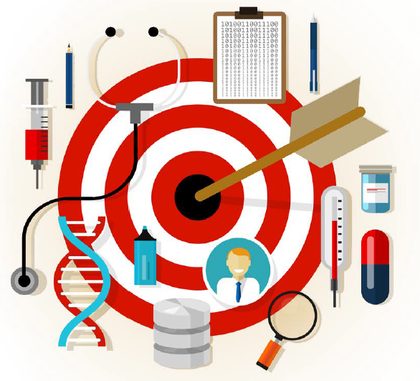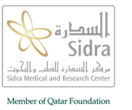

Sidra Symposia Series

**Functional Genomics: Towards Precision Medicine**

December 11-13, 2017

**Table of Contents**

Welcome message from Dr. Khalid Fakhro ………………………………………………………………………… 1

The Scientific Organization Committee ……………………………………………………………………………… 4

The Supporting Organizing Committee ………………………………………………………………………………. 5

Target Audience and Learning Objective …………………………………………………………………………… 6

Program schedule (English)…………………………………………………………………………………..……………. 7

Speakers’ and Moderators biographies………………………………………………………..……..………………

Information about Sidra Medicine………………………………..……..……………………………………………..

Information about the Research Branch……………………………………………………..………………………

About Qatar ………………………………………………………………………………………………………………………

Note page………………………………………………………………………………………………..….………………………

**Welcome Message**

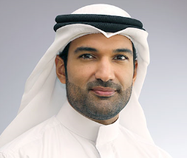

**Khalid A. Fakhro, PhD**

Director of Human Genetics

Translational Medicine Division, Research Branch

Sidra Medicine

Dear Colleagues,

Welcome to Doha!

It is our pleasure to welcome you to Sidra’s Third Annual Functional Genomics Symposium, co-organized with *Nature Genetics*. The Functional Genomics series is designed to showcase world-class scientific progress that aligns with Qatar’s national vision for building academic and clinical capacity in genomic medicine. This year’s theme, “Towards Precision Medicine,” will feature exceptional content covering the many aspects of this rapidly-developing field. The path towards Precision Medicine has witnessed unprecedented growth in recent years, and we sincerely hope the event we organized will inspire scientists and healthcare professionals alike.

This year, our scientific committee worked diligently with our co-organizers at *Nature Genetics*, to bring together world-renowned international and local thought leaders. Our speakers are not only tackling some of the toughest disorders – from orphan monogenic conditions to autism and cancer – but are also at the forefront of building technologies that improve the quality and precision of clinical practice. The symposium will kick-off with efforts in Qatar and the region, followed by a session highlighting the potential of combining genomics and community driven projects (*big data* and *big cohorts*) for translational medicine. Day 2 will focus on the application of precision medicine to a wide spectrum of diseases, from complex disorders and cancer, to pediatric and maternal-fetal health. And day 3 will highlight the new and exciting ways in which clinical practice is becoming more personalized through multidisciplinary technological advances.

Taken together, our symposium reinforces the notion that tackling and improving population health will require multidisciplinary, multi-stakeholder cooperation between academic researchers, healthcare professionals, policy makers and the community at large. In this respect, we are fortunate to host this meeting in Qatar, a nation undergoing large-scale transformation to a knowledge-based economy by placing high-quality education and research at the forefront.

My heartfelt thanks go to Sidra’s Scientific Organizing and Supporting Events Committees and to *Nature Genetics* for the tireless dedication to organizing this event. I also wish to express sincere gratitude to the entire program faculty who have volunteered their precious time and expertise to be with us, and to our sponsors for their support of our event. Finally, I’d like to thank you, our meeting attendees, and ask you to engage and challenge our speakers in order to make this a wonderful learning opportunity for us all. I sincerely hope you will enjoy the Symposium and Doha!

Respectfully,



Dr. Khalid A. Fakhro

**The Scientific Organizing Committee**

**Khalid Fakhro**, Director of Human Genetics

**Justin Konje**, Executive Chair- Women’s Clinical Management Group

**Khalid Hussain**, Division Chief- Endocrinology

**David Bedognetti**, Director- Tumor Biology

**Marios Kambouris**, Senior Attending Physician

**Younes Mokrab**, Investigator

**Xavier Estivill**, Investigator

**Tomoshige Kino**, Investigator

**Luis Saraiva,** Investigator

***Souhaila Al Khodor***, Investigator

**Annalisa Terranegra**, Investigator

***Mohammad Haris***, Investigator

**Nico Marr**, Investigator

***Puthen Jithesh***, Investigator

**Louis Herlands**, Executive Director

**The Supporting Organizing Committee**

**Nelly EL Mistekawy**, CRO Office Manager

**Rana Hamada**, Executive Assistant

**Maria Theresa Brunsman**, Executive Assistant

**Irina Chepilevskaya**, Project Analyst

**Lara Djansezian**, Business Analyst

**Maricris Salud**, Sr. Admin Assistant

**Nevin Amin**, Sr. Admin Assistant

**Hamda Zain Al Abdeen**, Communications Event Specialist

**Fadi Hamsho**, Lead – Web Projects & Development

**TARGET AUDIENCE:**

The Sidra Functional Genomics Symposium is directed towards physicians, nurses, pharmacists, healthcare policy makers, scientists, academic researchers and students involved in the field of biology, genomics, genomic medicine, genetics, cancer and other chronic diseases.

**Conference Objectives**

* Learn about ongoing efforts towards precision medicine in the region.
* Learn about how precision approaches can improve Maternal, Fetal and Pediatric Healthcare.
* Learn about the contribution of genomics to complex disorders.
* Understand novel approaches and emerging technologies enabling precision clinical practice.

*Disclosure:*

*The Scientific Planning Committee (SPC) has reviewed all disclosed financial relationships of speakers, moderators, facilitators and/or authors in advance of this CPD activity and has implemented procedures to manage any potential or real conflicts of interest*

|  |  |  |  |  |
| --- | --- | --- | --- | --- |
| **Day 1: Monday 11 December 2017** | | | | |
| 07:00 – 8:00 | Registration and refreshments | |  | | |
| **Introduction session Objective:** | **Introduction and overview of Sidra Research achievements/ updates on Qatar Genome Programme and Qatar Foundation Research Strategy** | | |
| 08:00 – 08:05 | **Welcome note**  Mr. Peter Morris  CEO, Sidra Medicine - Qatar | |  | | |
| 08:05 – 08:10 | **Overview of Sidra Research Achievements**  Dr. Ena Wang  Sidra Medicine - Qatar |  | | |
| 08:10 – 08:15 | **The Functional Genomics Symposium Series**  Dr. Khalid Fakhro  Chair of the Functional Genomics Symposium 2017 | |  | | |
| 08:15 – 08:40 | **“Qatar Genome Programme: Coming of Age”**  Dr. Asma Al Thani  Qatar Genome Program- Qatar | |  | | |
| 08:45 – 09:05 | **“QF R&D Biomedical Research Strategy: Beyond Mission Driven Research”**  Dr. Hadi Abderrahim  Qatar Foundation Research and Development- Qatar | |  | | |
| 09:10 – 09:50 | **“Autism spectrum disorder: genomes to precision medicine applications”**  Opening Keynote: Dr. Stephen Scherer  Hospital For Sick Children- Canada | |  | | |
| 09:50 – 10:05 | **Coffee break** | | | |
| **Day 1 Session 1: Efforts Towards Personalized Medicine in The Middle East**  Moderator: Dr. Ibrahim Janahi , Sidra Medicine – Qatar  **Objective: To learn about ongoing projects in the region focused on personalized medicine** | | | | |
| 10:05 – 10:40 | **“Medical Genetics & Genomic Medicine in Turkey”**  Keynote speaker: Dr. Tayfun Özçelik  Bilkent University - Turkey | | | |
| 10:45 – 11:10 | **“Precision Medicine in Oman: Success and Challenges”**  Dr. Anna Rajab  Muscat Private Hospital and Burjeel Hospital - Oman | | | |
| 11:15 – 11:40 | **“Immunogenomics: Towards Personalized Cancer Treatment”**  Dr. Davide Bedognetti  Sidra Medicine - Qatar | | | |
| 11:45 – 12:05 | **“Peoteomics And Systems Biology For Personalization Of Cancer Treatment”**  Dr. Serhiy Souchelnytskyi  College of Medicine, Qatar University - Qatar | | | |
| 12:10 – 12:30 | **“Personalized Medicine In GI, Past, Present And Future”**  Dr. Mamoun Elawad  Sidra Medicine - Qatar | | | |
| 12:30 – 13:40 | **Lunch break** | | | |
| **Day 1 Session 2: Genomics in Precision Medicine: Large Cohorts Studies**  Moderator: Dr. Luis Saraiva, Sidra Medicine – Qatar  **Objective: To learn about the power of large cohort studies for precision medicine** | | | | |
| 13:40 – 14:15 | **“De Novo Mutations in Health and Disease”**  Keynote speaker: Dr. Joris Veltman  Newcastle University - UK | | | |
| 14:20 – 14:45 | **“Deciphering the Genome: Community Driven Approaches”**  Dr. Heidi L. Rehm  Harvard Medical School - USA | | | |
| 14:50 – 15:15 | “The Path Of Precision Medicine: From Discovery To Patient Care”  Dr. Alan Shuldiner  Regeneron Genetics Center - USA | | | |
| 15:15 – 15:30 | **Coffee break** | | | |
| Moderator: Dr. Nahla Afifi , Qatar Bio Bank - Qatar | | | | |
| 15:30 – 16:00 | “Using Massive Global Reference Datasets Online”  Dr. Simonne Longerich  WuXi NextCODE - USA | | | |
| 16:05 – 16:30 | “Genetics Of Metabolic Traits: Lessons From Isolated Populations”  Dr. Torben Hansen  University of Copenhagen - Denmark | | | |
| 16:35 – 17:00 | **“Towards Precision Medicine In Arab populations: Lessons from thousands of Qataris”**  Dr. Khalid Fakhro  Sidra Medicine - Qatar | |  | | |
| 17:00 – 17:05 | **Closing remarks** | |  | | |

|  |  |  |
| --- | --- | --- |
| **Day 2: Tuesday 12 December 2017** | | |
| 07:00 – 7:30 | Registration and Refreshments |  |
| 07:35 – 08:45 | **Competitive travel abstracts presentations – 3 talks @ 20 minutes each**  Moderated by Prof. Khaled Machaca - Weill Cornell Medicine – Qatar | |
| **Day 2 Session 1: Precision Medicine in Chronic Diseases and Cancer**  Moderator: Prof. Khaled Machaca - Weill Cornell Medicine – Qatar  **Objective: To learn about how precision medicine information is being used to study complex disorders and cancer** | | |
| 08:50 – 09:25 | **“Mainstreaming Cancer Genetic Testing”**  Keynote speaker: Dr. Nazneen Rahman  The Institute of Cancer Research - UK | |
| 09:30 – 09:55 | **“Amyotrophic Lateral Sclerosis: Genetics In Opening New Therapeutic Avenues”**  Dr. Christopher E Shaw  Institute of Psychiatry, Psychology and Neuroscience - UK | |
| 10:00 – 10:25 | **“Managing Health and Disease Using Omics and Big Data”**  Dr. Tejaswini Mishra  Department of Genetics, Stanford University School and Medicine - USA | |
| 10:30 – 10:45 | **Coffee break** | |
| Moderator: Dr. Farah Zahir, Hamad bin Khalifa University- Qatar | | |
| 10:50 – 11:15 | **“Personalized Medicine in Cancer”**  Dr. Arash Rafi  Weill Cornell Medicine - Qatar | |
| 11:20 – 11:45 | **“Direct-to-Consumer Predictive Genomics DNA Profiling”**  Dr. Marios Kambouris  Sidra Medicine - Qatar | |
| 11:50 – 12:15 | **“Cancer Genetic Program Experience From Qatar”**  Dr. Salha Bujassoum  National Center for Cancer Care and Research - Qatar | |
| 12:20 – 13:45 | **Lunch break** | |
| **Day2 Session 2: Personalized Medicine in Early Life (Fetal Maternal and Pediatrics)**  Moderator: Dr. Jan Olofsson , Sidra Medicine – Qatar  **Objective: To learn about new ways that personalized medicine is being applied to childhood disorders and maternal medicine** | | |
| 13:45 – 14:20 | **“Cell Free Nucleic Acid For Prenatal And Postnatal Assessment”**  Keynote speaker: Dr. Lee Shulman  Northwestern University – USA | |
| 14:25 – 14:50 | **“Improving Care Through Genomic Medicine: Neonatal Diabetes As A Case Example”**  Prof. Sian Ellard  University of Exeter Medical School, Royal Devon & Exeter Hospital - UK | |
| 14:55 – 15:20 | **“Discovering genes of large effect in very early onset psychosis and other rare and orphan conditions”**  Dr. Catherine Brownstein  Boston Children's Hospital and Harvard Medical School - USA | |
| 15:25 – 15:35 | **Coffee break** | |
| Moderator: Dr Marios Kambouris, Sidra Medicine - Qatar | | |
| 15:35 – 16:00 | **“A Platform For Personalized Cystic Fibrosis Medicine"**  Dr. Shafagh Waters  miCF Research Centre - Australia | |
| 16:05 – 16:30 | **“The Reality Of Precision Health For Pediatric Immune Defects”**  Dr. Stuart Turvey  The University of British Columbia - USA | |
| 16:35 – 17:00 | **“Molecular Diagnosis Of Immune Dysregulation Disorders Lead To Targeted Treatments”**  Dr. Bernice Lo  Sidra Medicine - Qatar | |
| 17:00 – 17:05 | **Closing remarks** | |

|  |  |  |
| --- | --- | --- |
| **Day 3: Wednesday 13 December 2017** | | |
| 07:00 – 07:25 | Registration and Refreshments |  |
| 07:25 – 08:25 | **Oral abstract presentations – 5 talks @ 10 minutes each**  Moderated by Dr Egon Toft, College of Medicine -Qatar University – Qatar | |
| **Day 3 Session 1: Novel Approaches and Technologies Enabling Precision Clinical Practice**  Moderator: Dr. Egon Toft , College of Medicine -Qatar University – Qatar  **Objective: To learn about new technologies and methods that are making medicine more personalized in the clinic** | | |
| 08:30 – 09:05 | **“The Enigma Consortium: Mapping Huan Brain Diseases With Imaging & Genomics In 50,000 Individuals From 35 Countries”**  Keynote speaker: Dr. Paul Thompson  University of Southern California – Los Angeles - USA | |
| 09:10 – 09:35 | **“Genome Assembly: Recent Update And Applications To Human Genomics”**  Dr. Jason Chin  Software, Whole Biome Inc - USA | |
| 09:40 – 10:05 | **“Precision Medicine In The Cardiac Catheterization Laboratory”**  Dr. Aimee Armstrong  Nationwide Childern’s Hospital - USA | |
| 10:10 – 10:25 | **Coffee break** | |
| Moderator: Dr. Younes Mokrab, Sidra Medicine - Qatar | | |
| 10:30 – 10:55 | **“The Future of HealthCare Delivery”**  Dr. Kamal Jethwani  Partners Healthcare, Harvard Medical School - USA | |
| 11:00 – 11:25 | **“Computational Tools And Repositories For Translational Medicine In The Post-Genomic Era”**  Dr. George Patrinos  University of Patras - Greece | |
| 11:30 – 11:55 | “**Artificial Intelligence In Medicine: A Practical Approach”**  Dr. Deepak Kaura  Sidra Medicine - Qatar | |
| 12:00 – 12:15 | **Poster awards distribution and closing remarks**  by Dr. Myles Axton, Nature Genetics - USA | |

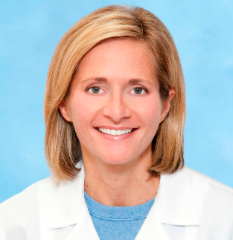**Speakers’ Biographies**

**Dr. Aimee Armstrong**

***Director of Cardiac Catheterization & Interventional Therapies***

**Nationwide Children’s Hospital**

**Ohio, USA**

Aimee Armstrong, MD, FAAP, FACC, FSCAI is the Director of Cardiac Catheterization & Interventional Therapies at Nationwide Children’s Hospital in Columbus, Ohio, where she is also an Associate Professor of Pediatrics at the Ohio State University College of Medicine. After graduating with her B.S. in Biology from the University of Michigan, she obtained her medical degree at Northwestern University Medical School. She then completed her pediatric training at Indiana University’s Riley Hospital for Children and her pediatric cardiology and interventional cardiology training at the University of Michigan in Ann Arbor, MI. She worked as an interventional cardiologist for 11 years at the University of Michigan, where she also served as the Associate Director of the Pediatric Cardiac Catheterization Laboratories and as the Physician Lead for the University of Michigan Congenital Heart Innovations Collaborative. Dr. Armstrong was the interventionalist for the University of Michigan fetal cardiac intervention team and served as the site principal investigator for multiple device trials. In her role at Nationwide Children’s Hospital, she is also the Director of the Interventional Cardiology Fellowship Program. She and her team performed the first fetal cardiac intervention in the state of Ohio. Dr. Armstrong is the Co-Director of the International Symposium on 3D Imaging for Interventional Catheterization in CHD (3DI3) and the Co-Director of the ACC Reducing Radiation Risk (RRR) Quality Improvement Program.

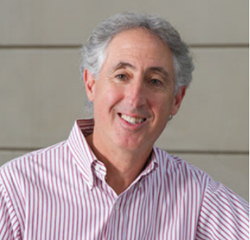

**Dr. Alan R. Shuldiner**

**Vice President**

**Regeneron Genetics Center**

**New York, USA**

Dr. Shuldiner received his undergraduate degree in chemistry from Lafayette College (Easton, PA; 1979), and his medical degree from Harvard Medical School (Boston, MA; 1984). He completed residency training in internal medicine at Columbia Presbyterian Hospital in New York, and his postdoctoral fellowship in Endocrinology and Metabolism in the Diabetes Branch at the National Institutes of Health in Bethesda. From 1991 to 1996, Dr. Shuldiner was a faculty member in the Division of Gerontology and Geriatric Medicine at Johns Hopkins University in Baltimore. From 1997-2014 he was a faculty member at the University of Maryland School of Medicine where he was the John Whitehurst Endowed Professor of Medicine, and served as Associate Dean and founding director of the Program for Genetics and Genomic Medicine, and Head of the Division of Endocrinology, Diabetes and Nutrition. Dr. Shuldiner’s major research interests lie in the molecular biology and genetics age-related diseases including of diabetes, obesity, osteoporosis, and cardiovascular disease, common disorders that contribute significantly to mortality, morbidity, and functional loss. He also works on the pharmaco- and nutri-genomics of these disorders. He is best known for his research in the Old Order Amish, a homogeneous founder population ideal for genetic studies. His multidisciplinary research team made several important genetic discoveries that have informed human biology and therapeutics including the first human null mutations in genes encoding apolipoprotein C-III (APOC3) and hormone sensitive lipase (LIPE), as well as discovery that common loss of function variants in CYP2C19 are major determinants of response to clopidogrel (Plavix) in coronary heart disease patients. In September 2014, Dr. Shuldiner became Vice President of the Regeneron Genetics Center where he continues to work in discovery and translational genomics, applying high-throughput sequencing and analytical approaches with academic collaborators throughout the world. Dr. Shuldiner has authored more than 350 original articles in leading journals and 70 reviews and book chapters. He is the recipient of a number of awards including the prestigious Paul Beeson Physician Faculty Scholar award, Ellison Medical Foundation Senior Scholar award, and 2006 University of Maryland Founders Day Researcher of the Year award. He has served on several steering and advisory committees and study sections related to his expertise in diabetes and related disorders, genomics, and translation of genetic discoveries to the clinical setting.

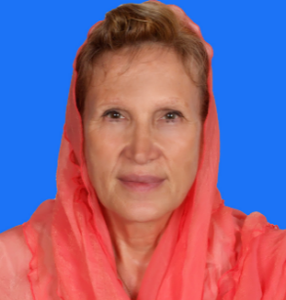

Dr Ismail is also the first president and co-founder of

**Dr. Anna Rajab**

**Consultant Clinical Geneticist**

**Ministry of Health**

**Muscat, Oman**

Dr. Anna dedicated 40 years of her life to the health service in the Sultanate of Oman and the last 20 of these were mainly in genetic services which resulted in an extraordinary achievement of a centralized genetic service. She is the founder of genetic service in Oman which started in 1992 with the aim to provide better care to those suffering with genetic disease and their families.

Her clinical services were supported by extensive educational programs and training.  She has trained more than 20 Omani scientists to perform genetic technologies and basic research in the field of genetics. These research activities, in collaboration with many centers in Europe and USA, gave her recognition and appreciation by many international organizations.  Dr. Anna has more than 60 publications to her credit. Subsequent to her clinical, research and educational activities, she became more involved in raising public awareness about genetic diseases and prevention of such disorders.

She’s the founder of National Genetic Service, with clinical genetic facilities, genetic diagnostic laboratories and the national program for prevention of genetic blood disorders. She has many national and international awards.  The best of these is the World Health Organization (WHO) award for research on Down’s syndrome. She’s the adviser for the WHO in genetic disorders and biotechnology.  She’s a member of many prestigious international societies such as the American Society for Human genetics, Human Genome Organization, European Society for Human Genetics and the British Genetics Society.  
 Her Contribution to the country of Oman for the past forty years to research on genetic diseases was highly appreciated. Through her initiative she founded and established many centers like Genetic services, community services, national program for the prevention of genetic blood disorders, premarital counseling, health education and data collection of genetic diseases in Oman. She has over 65 peer-reviewed international high quality publications.

[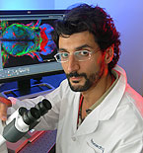](http://qatar-weill.cornell.edu/faculty/about-our-faculty/faculty-at-wcm-q/jeremie-arash-rafii-tabrizi)

**Dr. Arash Rafii Tabrizi**

**Associate Professor of Genetic Medicine in Obstetrics/Gynecology**

**Weill Cornell Medicine**

**Doha, Qatar**

Dr. Rafii received an M.D. from the Université Paris V René Descartes and a Ph.D. in Molecular Oncology from the Université Paris XI, Kremelin Bicetre. Subsequently, he was a resident in Gynecology-Obstetrics at the Assistance Public-Hopitaux de Paris and a Fellow in Gynecologic Oncology at the Institut Claudius Regaud, Toulouse. Additional academic positions held by Dr. Rafii include Research Fellow at Washington University, St. Louis, Assistant Professor at the Université Paul Sabatier, Toulouse, and Junior Faculty member at INSERM, U872, Paris. From 2007 to 2008, he was an attending physician in Gynecologic Oncology at the Institut Claudius Regaud, Toulouse, France.

Dr. Rafii's research focuses on stem cell science and gynecologic oncology, in particular the role of the interaction between mesenchymal stem cells and cancer cells in the acquisition of chemoresistance. At Weill Cornell Medicine - Q (WCM-Q), his research focuses on ovarian cancer and stem cell biology. Through collaboration with WCMC Department of Genetic Medicine as well as the Ansary Stem Cell Center for Regenerative Medicine, his laboratory uses a system biology approach to stroma mediated cancer resistance as well as to organ regeneration. He has also set up s specific program to investigate the use of Next gene sequencing platforms to set up a personalized medicine approach to advanced cancers. In this program his group is investigating notions such as cancer heterogeneity during metastatic spread and tailored targeted therapy in advanced cancer.



**Professor Asma Al-Thani**

**Chair of National Genome Qatar**

**Qatar Genome Programme**

**Doha, Qatar**

Dr Asma Al-Thani is a Professor of Virology at the Biomedical Science Department - College of Health Sciences. Dr Al-Thani obtained her Ph.D degree in (2005) from the University of London in the United Kingdom.

Dr Al-Thani also fulfills roles as Founding Dean of College of Health Sciences on 2016, First Director of Biomedical Research Center at Qatar University from Fall 2014, as Vice Chairperson of the Qatar Biobank Board since 2010 at Qatar foundation, Chair of National Genome Qatar Committee since December 2013, and Adjunct Assistant Professor in the Department of Microbiology and Immunology at Weill Cornell Medical College in Qatar since 2011.

Dr Al-Thani has numerous published articles in her field of expertise including, more than 50 published papers in peer-reviewed international journals. She has also obtained several research grants, including 7 Qatar university grants, 13 UREP grants and 4 NPRP grants. She was the recipient of the First Prize of Sheikh Hummaid Bin Rashid for Culture and Sciences for research on Bird Flu and means of prevention in December 2006 and was awarded a prize, from the Al-Jasra Cultural Club-Qatar for student research competition titled, Variety of resident nationalities in Qatar and its effect or presence of new disease in the Qatari society in April 2008. Dr Al-Thani was given recognition through the Qatar University Outstanding Faculty Service Award in 2012. College of Arts and Sciences Research wards 2012 and Arab Paediatric Medical Research Awards 2015. Best student award Poster in the field of Health, Biomedical Sciences in Qatar Foundation Research Forum 2012, 2nd Winner of Qatar National Research Fund (QNRF)’s Sixth Annual UREP Competition 2014 and 2nd Winner of Qatar University Research award 2015.

Dr Al Thani services in several external committees, some of them still active: Institutional Review Board and Institutional Bio-Safety Committee- Weill Cornell Medical College in Qatar, Qatar Health Research Ethics Committee, and National Cancer Research committee. She works as reviewer for several scientific journals and conferences and is a member in the American society for Microbiology.

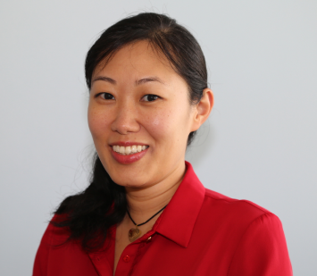

**Dr. Bernice Lo**

**Investigator- Human Genetics**

**Sidra Medicine**

**Doha, Qatar**

Dr. Bernice Lo is an investigator at Sidra Medicine. She received her Ph.D. in Cell Biology at Duke University and her post-doctoral training at the National Institutes of Health in the U.S. Dr. Lo is most known for her contribution in the discovery and molecular understanding of the two new

autoimmune disorders, CHAI and LATAIE. She has also contributed to the diagnosis and study of various other disorders of immune dysregulation. Dr. Lo’s laboratory is focused on understanding the molecular mechanisms of immune regulation and tolerance. Her approach includes studying patients with immune dysregulation and autoimmunity, identifying the genetic basis of disease and the molecular pathways involved. Dr. Lo’s lab specializes in using cellular and biochemical techniques to uncover the role of newly discovered gene mutations in causing disease and in understanding the function of these genes in immune regulation.

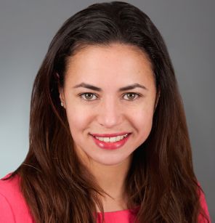

**Dr. Catherine Brownstein**

**Scientific Director for Orphan Disease Research**

**Boston Children’s Hospital/Harvard Medical School**

**Massachusetts, USA**

Dr. Brownstein is the Scientific Director for the Manton Center for Orphan Disease Research at Boston Children’s Hospital and Harvard Medical School.  Specializing in gene discovery, Dr. Brownstein has been instrumental in the elucidation of several new disease genes for conditions such as intellectual disability, nemaline myopathy, very early onset psychosis, SIDS, and hypophosphatemic rickets. As part of the Innovation and Digital Health Accelerator at Boston Children's Hospital, she is also a conduit between academics and industry, producing innovative technology approaches and partnerships. Dr. Brownstein's current work focuses on advancing the fields of next generation sequencing and analysis.

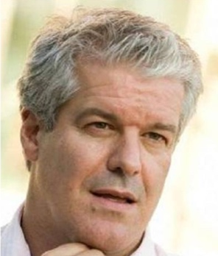

**Dr. Christopher Shaw**

**Professor of Neurology**

**King’s College London**

**London, England**

Christopher Shaw is Professor of Neurology and Neurogenetics at the Institute of Psychiatry, Psychology and Neuroscience, King’s College London. He is Head of the Department of Basic and Clinical Neuroscience and Director of the Maurice Wohl Clinical Neurosciences Institute leading a faculty of 35 and 170 staff and PhD students. He also works as a Consultant Neurologist at King’s College Hospital where he runs a clinic for people with motor neuron disorders.

His early clinical training in General Medicine and Neurology was conducted in New Zealand. He came to Cambridge, UK in 1992 on a Wellcome Trust Fellowship to study Neurobiology. After 3 years studying the molecular signalling between neurons and oligodendroglia he moved the Institute of Psychiatry in 1995. Over the past 20 years his team have created one of the world’s largest Biobanks of DNA samples, lymphoblast cell lines and post mortem tissues from patients with ALS. This has underpinned his research exploring the genetics, molecular and cellular pathobiology of ALS.

His contributions to the field include the identification of many novel SOD1 mutations and description of the associated molecular pathology. His team were the first to identify mutations in TARDBP, which encodes TDP-43 in familial and sporadic ALS and demonstrate their neurotoxicity. They have subsequently identified the proteins that regulate TDP-43 nucleo-cytoplasmic shuttling, identified the major RNA binding targets and the pathways regulating its proteostasis. They have generated mutant TDP-43 transgenic mouse and patient induced pluripotent stem cells IPS-derived neurons and glia from TDP-43 mutant patients recapitulate key features of human ALS pathology.

Using genome-wide linkage they identified a novel locus for familial ALS on chromosome 16q and subsequently identified mutations (FUS) in ~3% of all familial cases. They were the first to demonstrate that FUS mutations disrupt the nuclear localising signal leading to cytoplasmic aggregates. They subsequently generated a transgenic mouse model with FUS overexpression leading to an ALS phenotype. They were the first to demonstrate linkage to Chromosome 9p in an ALS and frontotemporal dementia (FTD) kindred subsequently shown by others to be an expanded G4C2 hexanucleotide repeat and the most common mutation for ALS and FTD. Subsequently they demonstrated the hallmark cerebellar pathology (Al-Sarraj 2011) and that specific RNA binding proteins are sequestered in RNA foci.

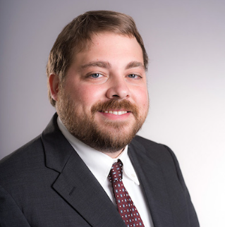

**Dr. Davide Bedognetti**

**Director- Tumor Biology Immunology and Therapy**

**Sidra Medicine**

**Doha, Qatar**

Dr. Bedognetti received his MD and PhD in Clinical and Experimental Oncology and Hematology from the University of Genoa, Italy. After completing his medical residency in Medical Oncology in 2008, he joined the Infectious Disease and Immunogenetics Section (IDIS) of the US National Institutes of Health (NIH) where he completed his post-doctoral fellowship. Since 2013, he served also the Director of the Federation of Clinical Immunology Societies (FOCIS) Center of Excellence at NIH Clinical Center. Dr. Bedognetti is Adjunct Associate Professor at the Hamad Bin Khalifa University in Doha. He has received several awards including the SITC Travel Award, the Merit and Young Investigator Awards of the Conquer Cancer Foundation of ASCO, and the ASH Travel Award. Since 2010 he has published more than 40 articles in peer-reviewed journals. Dr Bedognetti is an active member of the Society for Immunotherapy of Cancer (SITC), American Society of Clinical Oncology (ASCO) and Federation of Clinical Immunology Societies (FOCIS). He currently serves as Editor of the Tumor Microenvironment Section for the Journal of Translational Medicine and as Editorial Board Member of Biomarkers Research. His research has been published in journals including Blood, Nature, Journal of the National Cancer Institute, Journal of Clinical Oncology, Journal of Immunology, Journal of Clinical Investigations, PNAS, Immunity, Clinical Cancer Research, British Journal of Cancer and Journal of Translational 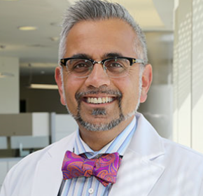Medicine.

**Dr. Deepak Kaura**

**Executive Chair- Foundation Medical Services**

**Sidra Medicine**

**Doha, Qatar**

Dr. Deepak Kaura is the Executive Chair – Foundation Medical Services (Radiology, Pathology, Anesthesia, Psychiatry, Peri Operative Services), previously inaugural Chair of Radiology Department of Sidra Medicine. In this role Dr. Kaura is responsible for leading Sidra’s radiology and imaging services, to ensure delivery of a high standard of patient-focused and transformative care. In addition, he will drive forward innovation in research and medical education to place Sidra at the forefront of radiology expertise and progress.

Dr. Kaura is a Pediatric Radiology Specialist with a wide breadth of experience in department leadership, radiology consulting, research and academia. Prior to joining Sidra, Dr. Kaura was Department Head of Diagnostic Imaging at Alberta Children’s Hospital in Canada. He also served as a Clinical Associate Professor in the Faculty of Medicine at University of Calgary, one of Canada’s top research universities.

In addition to his notable clinical and academic career, Dr. Kaura has a well-deserved reputation for innovation in radiology and imaging. He has founded or served as strategy and product consultant to numerous technology companies focused on advancements and developments in radiology. Dr. Kaura also co-founded the Advanced Center for Radiology in Dubai, known for its high standard of practice in the region.

Dr. Kaura has been the recipient of numerous honors and awards for his research and work in radiology and has held several committee and board level positions in medical organizations, including Chair of the Pediatric Radiology Subspecialty for the Royal College of Physicians and Surgeons of Canada.

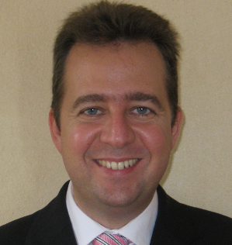

**Dr. George Patrinos**

**Associate Professor of Pharmacogenomics & Pharmaceutical Biotechnology**

**University of Patras**

**Patras, Greece**

George P. Patrinos obtained his PhD in Molecular Biology and Genetics from the University of Athens (Greece). He currently serves as Associate Professor of Pharmacogenomics and Pharmaceutical Biotechnology in the University of Patras (Greece), Department of Pharmacy and holds adjunct Professorships at Erasmus MC, Faculty of Medicine, Rottetrdam (the Netherlands) and the United Arab Emirates University, College of Medicine, Department of Pathology, Al-Ain (UAE). Also, he is Greece’s National representative in the CHMP Pharmacogenomics Working Party of the European Medicines Agency (EMA, London, UK) and Scientific Director of the Golden Helix Foundation (London, UK), an international non-profit research organization in the field of Genomic Medicine.

His research interests involve discovery work and clinical implementation of pharmacogenomics, genomics of rare disorders and transcriptional regulation of human fetal globin genes. His group is also internationally recognized for its involvement in developing National/Ethnic Genetic databases to document the genetic heterogeneity in different populations worldwide and of genome informatics tools to translate genomic information into a clinically meaningful format, while he also has a keen interest in public health genomics to critically assess the impact of genomics to society and public health.

George has more than 180 publications in peer-reviewed scientific journals and textbooks, some of them in leading scientific journals, such as Nature Genetics, Nature Rev Genet, Nucleic Acids Res, Genes Dev, and he is the Editor of the textbook “Molecular Diagnostics”, published by Academic Press, now in its 3rd edition. Furthermore, he serves as Associate Editor and member of the editorial board of several scientific journals, he has been a member of several international boards and advisory and evaluation committees and he is the main organizer of the Golden Helix Conferences, an international meeting series on Pharmacogenomics and Genomic Medicine. He has given numerous keynote and plenary lectures in international conferences as invited speaker and his research projects received funding from national and international funding agencies.



**Dr. Hadi Abderrahim**

**Lead Strategy for Healthcare and Biomedical**

**Qatar Foundation**

**Doha, Qatar**

Before joining QF R&D as Lead Strategy for Healthcare and Biomedical, Dr Hadi Abderrahim led Qatar Biobank as its managing director.

Dr Hadi Abderrahim’s previous experiences range from academic settings (CEPH, Cold spring Harbor, Stanford University) to Biotechnology and Pharmaceutical industry.

More than 20 years’ experience in human genetics and biomarker development, studying the effect of genetic factors on reactions to drugs and personalised medicine.

As Head of Genetics and Biomarkers at Merck Serono, a pharmaceutical company based in Geneva, Dr Abderrahim oversaw the strategies for patient stratification in personalized medicine and established a central Biobank based in Italy.

Prior to that, as Head of Genetics and Genomics Platforms at Genset in Paris, Dr Abderrahim set up a genetic and genomic platform with application to studying complex traits and diseases and a Pharmacogenetics team devoted to identify responders to drug treatments. He obtained his M.D. speciality in Genetic counseling from Hopital Necker, Paris, and he has a Ph.D. in Human Genetics and an executive MBA from HEC Paris.

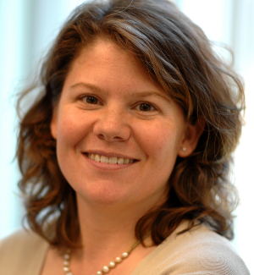

**Dr. Heidi L. Rehm**

**Chief Laboratory Director/Medical Director/Associate Professor**

**Partners Laboratory for Molecular Medicine/Harvard Medical School**

**Massachusetts, USA**

Heidi L. Rehm, PhD, FACMG is a board-certified clinical molecular geneticist and genomic medicine researcher. She is the Chief Laboratory Director at the Partners Laboratory for Molecular Medicine (LMM), the Medical Director of the Broad Institute Clinical Research Sequencing Platform and Associate Professor of Pathology at Brigham & Women's Hospital and Harvard Medical School. Both clinical labs focus on the rapid translation of new genetic discoveries into clinical tests and bringing novel technologies and software systems into molecular diagnostics to support the integration of genetics into clinical and translational use. The LMM has been a leader in translational medicine, launching the first clinical tests for cardiomyopathy and lung cancer treatment. The LMM and the Broad CRSP lab offer genomic sequencing services for both clinical diagnostics and to support several genomic medicine research projects including the MedSeq and BabySeq projects and the eMERGE program.

Dr. Rehm is also involved in defining standards for the use of next generation sequencing in clinical diagnostics and the interpretation of sequence variants through her committee roles at the American College of Medical Genetics and Genomics. She is also one of several principal investigators of a major NIH-funded effort called ClinGen (Clinical Genome Resource) to support broad sharing of genotype and phenotype data and expert interpretation of genes and variants. Working closely with the Global Alliance for Genomics and Health she is co-leading the Matchmaker Exchange project to aid in solving rare diseases and co-chairs a subcommittee of the BRCA Challenge to support the international sharing of knowledge on BRCA variation. Dr. Rehm also co-leads a Center for Mendelian Genomics and is helping launch new initiatives in healthcare IT.

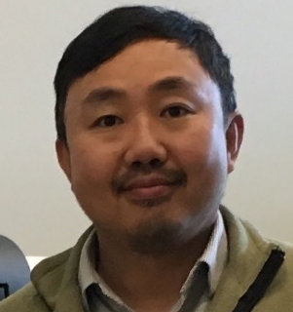

**Dr. Jason Chin**

**Software Engineer**

**Whole Biome Inc**

**California, USA**

Jason Chin was trained in theoretical physics in University of Washington. During the Human Genome Project, he started to get interested in DNA sequence analysis and bioinformatics in early 2000's. Starting in 2002, he switched his research focus from physics to bioinformatics as a postdoctoral scholar in University of California, San Francisco. In UCSF, he studied gene regulations with microarray data. Later, beside pure computational work, he developed experimental methods for studying real time protein expression dynamics. He joined Pacific Biosciences in 2008 developing bioinformatics methods and building automatic analytic platform for improving DNA sequencing systems' performance. Since 2013, his major work was on developing genome assembly algorithms and software for long-read data. It led to several novel algorithms and processes for effectively using PacBio long read data to assemble genomes. The current topic he is focusing on are (1) improving assembly computational performance, (2) developing algorithm for diploid genome and (3) understanding the fundamental mathematical properties in the genome assembly problem.

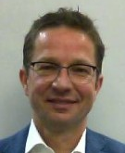

**Dr. Joris Veltman**

**Director of the Institute of Genetic Medicine**

**Newcastle University**

**Newcastle upon Tyne, UK**

Dr. Joris has been fascinated by the possibilities of genomics technologies to study the causes of human disease ever since these technologies became available. In the last 8 years he has been using next generation sequencing technology to improve the detection of all forms of genomic variation and study their role in human disease, using intellectual disability (ID) as a model disease. In 2010 his group was the first to use this approach to successfully identify dominant de novo disease gene mutations causing rare ID syndromes. Next, they pioneered exome sequencing in patient-parent trios to reliable identify de novo disease gene mutations in common forms of ID. Following this success they implemented exome sequencing in routine diagnostics. In their research they recently performed a first pilot study in which they studied de novo mutations using state-of-the-art genome sequencing technology. They demonstrated for the first time that genome sequencing can identify the major causes of severe ID, with de novo coding mutations explaining disease in 60% of cases. This ultimate genetic test allows them to study mutational processes, establish links between the occurrence and frequency of these mutations and risk factors such as paternal age, and start to look at disease causing mutations in the non-coding part of our genome. In the coming years he wants to expand his research on the role of de nova mutations to other disorders including male infertility and early-onset Alzheimer's disease. It is also his ambition as Professor in Translational Genomics to implement genome sequencing as soon as possible into routine diagnostics, albeit in a responsible manner. The combination of fundamental research, technology development and clinical application in human genetics is to him both challenging and promising. His ultimate goal is to advance medical sciences by integrating his knowledge on the impact of genome variation in routine clinical decision making.

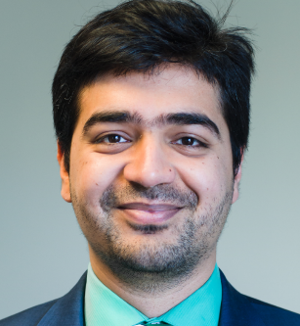

**Dr. Kamal Jethwani**

**Senior Director of Connected Health Innovation**

**Partners Healthcare**

**Massachusetts, USA**

As the Senior Director of Connected Health Innovation (CHI), Kamal Jethwani is responsible for leading a multidisciplinary team to identify and solve challenges in healthcare delivery using innovative technology-based solutions. CHI embraces value-based reimbursement across all care settings, and its solutions enable improved outcomes by making care delivery a continuous function of patients’ lives. His team is engaged in needs assessments across the system, product development and evaluations, and rigorous research to prove the value and outcomes of using connected health solutions. Their innovations are routinely scaled within clinical practices at Partners, and made part of the usual care provided to Partners’ patients. Kamal is also actively engaged in working with industry partners to scale innovations outside of Partners through strategic partnerships and licensing opportunities.

The core focus of his research is in enabling better care delivery through connected health programs, by enabling better patient engagement, patient-provider communication, and patient satisfaction with care. His research so far has shown that programs that are personalized to each patient’s unique psychology and needs forge higher engagement, and in turn better outcomes. Kamal continues to develop analytic and programmatic modalities to improve the understanding of personalization concepts to connected health. He has worked extensively with sensor technology, wearables, and mobile as well as social media to deliver care to patients. The ability to personalize care and understand behavioral motivations that dictate health choices remains central to all his work at Partners CHI.

**Dr. Khalid Fakhro**

**Director- Human Genetics**

**Sidra Medicine**

**Doha, Qatar**

Dr Khalid A. Fakhro is the Director of Human Genetics at Sidra Medicine and Assistant Professor of Genetic Medicine at Weill Cornell Medical College in Qatar. He obtained a Bachelor’s degree with Honors in Cell Biology and Molecular Genetics from the University of Chicago and subsequently his Ph.D. in Human Genetics at Yale University, where he was part of a highly selective Howard Hughes Medical Scholars program focused on translational medicine applications to human disease. Dr. Fakhro has been publishing high-impact research in human genomics and personalized medicine in Qatar, bringing along a decade of first-hand experience in high-throughput data generating platforms including a range of high-density genotyping microarrays and next-generation sequencing platforms, as well the use of multiple model organisms to study human disease. Currently, his work focuses on employing new genomics technologies to discover genes responsible for Mendelian disease and previously un-described congenital syndromes in the Qatari population. Dr Fakhro’s lab has also been awarded several large national grants to work on human disease and population genomics in Qatar, with a focus on using new bioinformatics tools to analyze large-scale genomics data to describe variation, population structure and predisposition to disease from thousands of Qatari genomes and exomes. His work positions him at the intersection of basic science and clinical investigation, collaborating with many local stakeholders in Qatar to achieve the national health goals in personalized medicine.

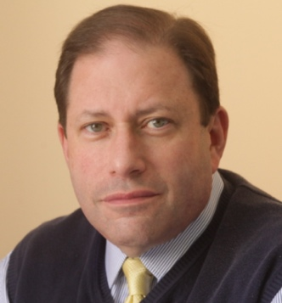

**Dr. Lee P. Shulman**

**Division Chief of Clinical Genetics**

**Northwestern University**

**Illinois, USA**

Lee P. Shulman MD is the Anna Ross Lapham Professor in Obstetrics and Gynecology and Chief of the Division of Clinical Genetics at the Feinberg School of Medicine at Northwestern University in Chicago, Illinois. He also serves as the Co-Director of the Cancer Genetics Program of the Robert H. Lurie Comprehensive Cancer Center of Northwestern University, the Director of the Northwestern Ovarian Cancer Early Detection and Prevention Program and the Medical Director of Insight Medical Genetics and Reproductive Genetics Innovations. Dr. Shulman is also an Adjunct Professor in the Department of Medicinal Chemistry and Pharmacognosy at the University of Illinois at Chicago College of Pharmacy. He is a Fellow of the American College of Obstetricians and Gynecologists and a Founding Fellow of the American College of Medical Genetics.

Dr. Shulman is a member of numerous regional, national and international organizations that pertain to the health and care of women. His work has been recognized regionally and nationally; most recently, he was again included in the list of “Top Doctors” in Chicago (2007-17) and the United States (2005-17). He serves as an Editor of the European Journal of Contraception and Reproductive Health and is the Executive Editor of the Journal of Gynecologic Surgery. He also serves on the editorial boards of Prenatal Diagnosis, Contraception, Menopause, Climacteric and as a peer-reviewer for 45 other journals. Dr. Shulman served as Chair of the Board of Trustees of the Association of Reproductive Health Professionals from 2006-2008 and is currently the President-Elect of the Central Association of Obstetricians and Gynecologists and the Chairman of the Fetoscopy Working Group. A frequent contributor to the peer-reviewed and informational literature with over 200 peer-reviewed articles and over 60 book chapters, Dr. Shulman’s major research interests are in reproductive and cancer genetics, contraception, menopause, women’s healthcare advocacy and botanical interventions in women’s health.

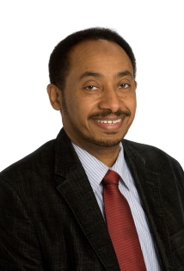

**Dr. Mamoun Elawad**

**Division Chief- Gastroenterologist**

**Sidra Medicine**

**Doha, Qatar**

Dr Elawad has his training in Pediatric gastroenterology at Great Ormond Street, Chelsea and Westminster Hospital, Oxford John Radcliff Hospital and King’s College Hospital. He worked as a consultant Pediatric gastroenterologist at University Hospital of Wales and Birmingham Children’s Hospital before he rejoined Great Ormond Street Hospital in 2002 as a consultant gastroenterologist and senior lecturer at the University College of London. He has been the head of the department at Great Ormond Street since 2007 until he joined Sidra Medicine in 2014 as a Chief of Pediatric Gastroenterology and director of inflammatory bowel disorders. Whist at GOSH, he became the founder and the director of the first worldwide pioneering program for Hematopoietic Stem Cell Transplant for autoimmune and inflammatory gut diseases. He was also the director of the department international collaboration “ImproveCareNow” at GOSH, and recently at Sidra, which involves 98 pediatric gastrointestinal units in the United States, with GOSH and Sidra being the only centers outside the United States. He was also the co-founder of the European GENIUS group that oversees the diagnosis and the treatment of children with early onset inflammatory bowel diseases. Dr. Elawad has been a senior lecturer at the Institute of Child Health – University College of London and his main research areas of interest are autoimmune gut disorders, genetics of inflammatory bowel disease, microbiota and genetic interaction in inflammatory gut diseases, Early Onset Inflammatory Bowel Disease and GI food allergy. He has many publications in these areas.

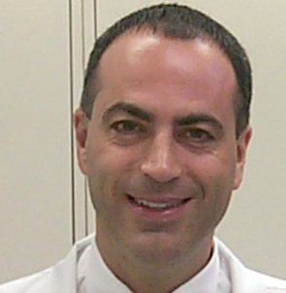

**Dr. Marios Kambouris**

**Acting Head-Pathology Genetics**

**Sidra Medicine**

**Doha, Qatar**

Certified by the American Board of Medical Genetics with dual certification: Clinical Molecular Genetics and Ph.D. Medical Genetics. Post-Doctoral fellowships in Clinical Molecular Genetics & Clinical Genetics at Henry Ford Hospital (Detroit, MI, USA). PhD degree in Medical & Molecular Genetics from Indiana University School of Medicine (Indianapolis, Indiana USA) and a BSc degree in Biochemistry & Molecular Biology from State University of New York (Buffalo, New York, USA).

Twenty-three years post-doctoral experience & expertise in Genetics, Genomics, DNA Diagnostics & Biotechnology both in scientific planning and business development including global alliances, venture capital recruiting and private investment fund raising. Established Gonidio LTD [Nicosia-Cyprus] and Geno-Type Biotechnology [Athens-Greece] offering Predictive Genomics and DNA Diagnostic Services. Established Gene Couture LTD formulating and producing NutraCeuticals & CosmeCeuticals based on Predictive Genomics DNA Profiling. Jointly responsible for the formulation of the scientific plan and for negotiating the formation of a Genomics company on behalf of the Research Center of King Faisal Hospital (Riyadh, Saudi Arabia) with British Aerospace Systems (part of an offset program) and Merlin Ventures (a UK based Venture Capitalist Company).

In Clinical Genetics extensive experience, examining, diagnosing, risk assessing, counseling and managing patients with a multitude of genetic disorders, congenital malformations, dysmorphia & mental retardation in Genetics clinics, in-patient consultations, field clinics, Growth clinics (skeletal dysplasias & growth abnormalities) and Neurology clinics (neurogenetic disorders) at Henry Ford Hospital (Detroit, MI, USA), Children’s Hospital of Michigan (Detroit, MI, USA) and Riley Hospital for Children (Indianapolis, IN, USA). Also risk assessing and Genetic counseling for high-risk pregnancy patients (maternal age, family history of genetic disorders, teratogenic exposures, abnormal MSAFP, etc.) in Prenatal Diagnosis clinics at Indiana University and Wishard Memorial Hospitals (Indianapolis, IN, USA).

In DNA Diagnostics, directed and/or established the Molecular Genetics & DNA Diagnostics laboratory at King Faisal Hospital & Research Center (Riyadh, Saudi Arabia), Geno-Type Biotechnology, (Athens, Greece), Gonidio International (Møgeltønder, Denmark), Shafallah Medical Genetics Center [Doha, Qatar] with extensive experience establishing, performing & interpreting DNA diagnostic testing, assessing and signing clinical and prenatal cases for genetic diseases.

Molecular Genetics research interest focused in mapping & identifying human disease genes and discovering novel pathogenic mutations. Involved in the localization and/or identification of more than twenty novel human disease genes and in utilization of populations with unique genetic characteristics for target gene discovery in polygenic, multi-factorial disorders.

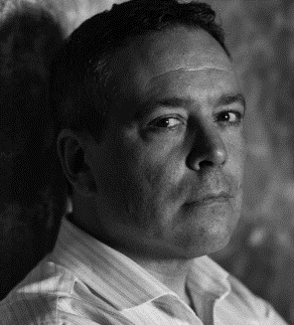

**Dr. Myles Axton**

**Chief Editor**

**Nature Genetics**

**New York, USA**

Myles Axton is the chief editor of Nature Genetics. He was a university lecturer in molecular and cellular biology at the University of Oxford and a Fellow of Balliol College from 1995 to 2003. He obtained his degree in genetics at Cambridge in 1985, and his doctorate at Imperial College in 1990, and between 1990 and 1995 did postdoctoral research at Dundee and at MIT’s Whitehead Institute. Myles’s research made use of the advanced genetics of Drosophila to study genome stability by examining the roles of cell cycle regulators in life cycle transitions. His interests broadened into human genetics, genomics and systems biology through lecturing and from tutoring biochemists, zoologists and medical students from primary research papers. Helping to establish Oxford’s innovative research MSc. in Integrative Biosciences led Myles to realize the importance of the integrative overview of biomedical research. As a full time professional editor he is now in a position to use this perspective to help coordinate research in genetics.

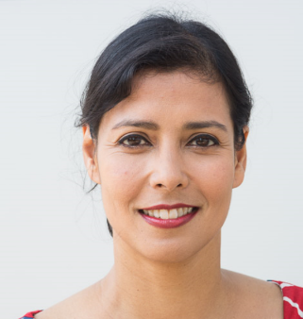

**Dr. Nazneen Rahman**

**Division Head of Genetics & Epidemiology**

**The Institute of Cancer Research**

**London, UK**

Professor Nazneen Rahman is [Head of the Division of Genetics and Epidemiology](http://www.icr.ac.uk/our-research/researchers-and-teams/professor-nazneen-rahman/professional-activities) at The Institute of Cancer Research (ICR), London, [Head of the Cancer Genetics Unit at The Royal Marsden NHS Foundation Trust](http://www.royalmarsden.nhs.uk/consultants-teams-wards/staff/consultants-r-z/pages/professor-nazneen-rahman.aspx), and Director of the [TGLclinical](http://www.icr.ac.uk/our-research/researchers-and-teams/professor-nazneen-rahman/professional-activities) gene testing laboratory at the ICR. She qualified in medicine from Oxford University in 1991, gained her CCST in Medical Genetics in 2001 and completed a PhD in Molecular Genetics in 1999.

Her research harnesses her scientific and clinical expertise to identify and clinically implement human disease genes. She has a strong focus on cancer predisposition genes, in which she is an internationally-recognised expert and has discovered many such genes during her career, particularly for breast, ovarian and childhood cancers.

Rahman is currently leading two innovative translational research programmes. The [Mainstreaming cancer genetics (MCG)](http://www.mcgprogramme.com/) programme is undertaking the technological, scientific and translational work required to make cancer predisposition gene testing part of routine cancer care. The [Transforming Genetic Medicine Initiative](http://www.thetgmi.org/) (TGMI) is building the knowledge base, tools and processes required to deliver the promise of genetic medicine.

Rahman has a strong commitment to open science and science communication and has garnered numerous awards, including a CBE in 2016 Queen’s birthday honours. In 2017, she was appointed as a Non-Executive Director for AstraZeneca’s Board of Directors and a member of the Science Committee.

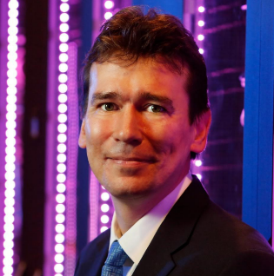

**Dr. Paul Thompson**

**Professor (Neurology, Psychiatry, Radiology, Pediatrics, Engineering, & Ophthalmology)**

**University of Southern California**

**California, USA**

Paul Thompson, Ph.D., directs the ENIGMA Center for Worldwide Medicine, Imaging & Genomics – a U.S. National Center of Excellence for “Big Data” analysis in biomedical research. In 2009, Dr Thompson co-founded and leads the ENIGMA consortium (http://enigma.usc.edu), a worldwide medical network of 340 institutions across 37 countries studying the major diseases of the brain. ENIGMA has published the largest neuroimaging studies of 5 major brain disorders – schizophrenia, bipolar disorder, major depression, ADHD and OCD – and also leads international studies of Alzheimer’s disease, Parkinson’s disease, epilepsy, as well as PTSD, anorexia, substance use, and anxiety disorders. In ENIGMA’s series of papers in Nature, Nature Neuroscience, and Nature Communications, 340 institutions pooled their DNA and MRI data to identify over a hundred genomic loci that influence brain structure and disease risk using massively-parallel distributed “big data” computing (Medland Nature Neuroscience 2015). ENIGMA discovers factors that affect the onset and progression of Alzheimer’s disease and other dementias, schizophrenia, depression and bipolar illness, HIV/AIDS, substance abuse, autism, and childhood brain disorders. Dr. Thompson’s group also created the first MRI maps of Alzheimer’s disease and schizophrenia spreading in the living brain, and a method to detect brain growth in children (published in the journal Nature). Thompson also directs the Imaging Genetics Center and serves as Associate Director of the new Stevens Institute for Neuroimaging and Informatics at the University of Southern California. At USC, he is a Professor of Neurology, Psychiatry, Radiology, Pediatrics, Engineering, and Ophthalmology. Dr. Thompson obtained his M.A. in Mathematics and Classical Languages from Oxford University, England, and his Ph.D. in Neuroscience from UCLA. His team of 30 researchers includes students in neuroscience, genomics, biomedical engineering, and biomedical physics. Collaborating with over 100 imaging labs around the world, Dr. Thompson’s 1,600 published research papers combine the talents of researchers in neuroimaging, mathematics, and clinical neurology (see http://igc.ini.usc.edu).



**Dr. Salha Bujassoum Al Bader**

**Senior Cosultant Medical Oncologist**

**National Center for Cancer Care and Research**

**Doha, Qatar**

Dr. Salha Bujassoum Al Bader has been a senior consultant at National Center for Cancer Care and Research (NCCCR) since 2005.She is a program director of high risk screening clinic, the clinical lead of the breast multi-disciplinary team, program director of medical oncology fellowship.

She is obtained her Medical Degree from king Saud University / Riyadh, Saudi Arabia in 1992. She received the specialist certificate in internal medicine/hematology from the royal college of physicians and surgeons of Canada, Toronto-Canada in 2001 and was certified by the American board of internal medicine/clinical hematology and medical oncology, Toronto, Canada in 2000, 2004.

Her academic appointments are as follows: in Hamad medical corporation, internship from 1991-1992 then residency in internal medicine from 1992-1995. In university of Toronto, Canada: residency in internal medicine (PGY1-PGY3) from 1996 to 1999 combined fellowship in clinical hematology and medical oncology from 2000 to 2003.

She joined Hamad Medical Corporation in 2003 as a consultant medical oncology and hematology. Currently her main focus is medical oncology subspecialized in breast and gynecological malignancy and her major interest cancer genetic.

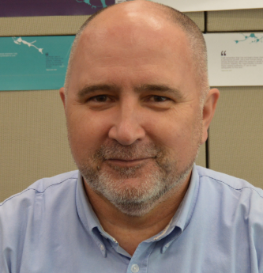

**Dr. Serhiy Souchelnytskyi**

**Professor**

**Qatar University**

**Doha, Qatar**

Dr. Serhiy Souchelnytskyi graduated from Lviv State University (1985) and obtained PhD degree at the Institute of Biochemistry (1992) in Lviv, Ukraine. Dr. Souchelnytskyi worked at the Institute of Biochemistry (Ukraine), INSERM U244 (France), Ludwig Institute for Cancer Research (Uppsala, Sweden), Karolinska Institutet and Karolinska University Hospital (Stockholm, Sweden), before joining Qatar University in 2015. He is involved in commercialization of research by developing diagnostic and personalization of cancer treatment.

Dr. Souchelnytskyi has 125 publications, including 5 patents. Dr. Souchelnytskyi is involved in editorial works as an Editor and a member of Editorial boards, works frequently for granting agencies as an expert, and has received awards in the area of proteomics and cancer biology.

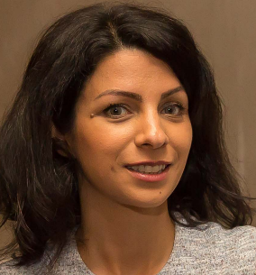Current projects are in development of personalized cancer medicine. Proteomics, systems biology and cancer signaling biology are used for individualized profiling of patients, their diagnostic and selection of the most efficient treatment.

**Dr. Shafagh Waters**

**Senior Research Associate & Lead Scientist**

**School of Women and Children’s Health**

**Doha, Qatar**

After completing her Masters in Genetics at the University of Otago, New Zealand on genetic biomarkers of adult brain tumours, Dr. Waters received a scholarship to complete her PhD at ANU in Canberra, which was on epigenetic regulation of X chromosome inactivation. Dr Waters was awarded her PhD in 2012 and headed to UNSW as a post-doctoral researcher studying non-coding RNA-directed changes to gene expression in various cell types and disease models.

From August 2016, Shafagh was appointed to senior research associate and lead scientist of the Australasian Centre for Personalised Cystic Fibrosis Medicine (ACPCFM) at the School of Women's and Children's Health at UNSW. Her main research project has a strong translational focus, and aims to discover small molecules and peptides that are effective in correcting the trafficking and functional defects exhibited by the CFTR mutation, while additionally addressing inter-individual human population variability.

Additionally, Dr Waters is using cutting edge technology to grow stem cell-derived human 'mini organs', or organoids, from the tissues of patients with cystic fibrosis.

Dr Waters has been successful in obtaining several research grants. She has collaborated with multiple leading global research groups for her work including Centre for gene therapy, City of Hope, USA. Dr Waters has been published in a number of journals including EMBO Journal, PLoS Genetics, Molecular Biology and Evolution and BMC Evolutionary Biology.

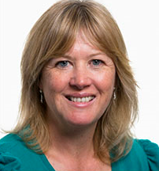

**Dr. Sian Ellard**

**Professor of Genomic Medicine**

**University of Exeter Medical School**

**Exeter, UK**

Sian is Professor of Genomic Medicine at the University of Exeter Medical School and also a Consultant Clinical Scientist at the Royal Devon and Exeter NHS Foundation Trust where she heads the Molecular Genetics Department. She came to Exeter in 1995 to set up a Molecular Genetics Laboratory providing a core facility for integrated research and diagnostic genetic testing. The laboratory receives samples from >75 countries throughout the world and is acclaimed for both its research into monogenic disorders and the translation of its research discoveries into diagnostic service.

Research interests include monogenic diabetes (with Professor Andrew Hattersley), congenital hyperinsulinism and applying next generation sequencing technology for disease gene discovery and improved diagnostic tests.

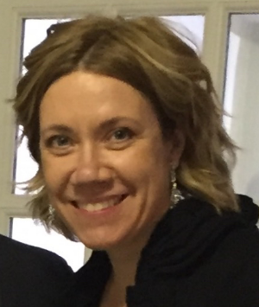

**Dr. Simonne Longerich**

**Senior Research Geneticist**

**WuXi NextCODE**

**Massachusetts, USA**

Simonne is a Senior Research Geneticist with WuXi NextCODE. Prior to WXNC, Simonne held an associate research scientist faculty position at Yale University where she was focused on biochemical characterization of proteins deficient in the rare genetic disease Fanconi Anemia. This research was an extension of her particular interest in DNA repair and genomic stability. As a PhD candidate in Immunology at the University of Chicago, she contributed to advances in understanding the molecular mechanism of somatic hypermutation in B lymphocytes, the process that generates high affinity antibodies during a humoral immune response. Her interest in genome stability began in the lab while pursuing her B.Sc. and M.Sc. in Genetics at the University of Alberta where she researched the genetic requirements for a specific mutational process that occurs in bacteria under stress, adaptive mutation.

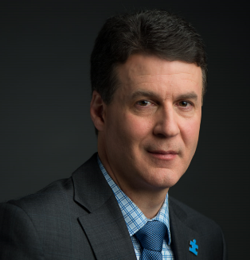

**Dr. Stephen Scherer**

**Chair in Genome Sciences**

**Hospital of Sick Children**

**University of Toronto**

**Ontario, CA**

Dr. Scherer holds the GlaxoSmithKline-Canadian Institutes of Health Research Endowed Chair in Genome Sciences at The Hospital for Sick Children (SickKids) and University of Toronto (UofT) and he is Director of the UofT McLaughlin Centre, as well as The Centre for Applied Genomics at SickKids. In 2004, his team contributed to the discovery of global gene copy number variation (CNV) as a common form of genetic variation in human DNA. His group then identified CNV to contribute to the aetiology of autism and many other disorders, and the Database of Genomic Variants he founded facilitates hundreds of thousands of clinical diagnoses each year. His research is documented in some 500 publications and he is one of the most highly cited scientists in the world. Dr. Scherer has won numerous honors such as the Steacie Prize, a Howard Hughes Medical Institute Scholarship, and the Premier’s Summit Award for Medical Research. He is a distinguished Fellow of the Canadian Institute for Advanced Research, the American Association for the Advancement of Science, and the Royal Society of Canada. In 2014, he was selected as a Thomson Reuters Citation Laureate in the field of Physiology or Medicine for “the discovery of large-scale CNV and its association with specific diseases”.

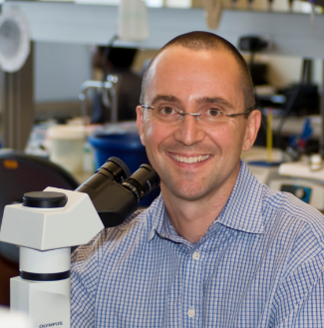

**Dr. Stuart Turvey**

**Professor of Pediatric Immunology**

**University of British Columbia**

**British Columbia, CA**

Stuart Turvey, MBBS, DPhil, FRCPC is a Professor of Pediatrics at the University of British Columbia where he holds the Aubrey J. Tingle Professorship in Pediatric Immunology.  He is a Pediatric Immunologist based at BC Children’s Hospital, and Director of Clinical Research at the Child & Family Research Institute.  Prior to coming to Vancouver, Dr Turvey completed both his Pediatric Residency and Allergy/Immunology Fellowship at Children’s Hospital, Harvard Medical School, Boston.  He holds a medical degree (MB BS) from the University of Sydney, Australia and a doctorate (DPhil) in Immunology from Oxford University where he was a Rhodes Scholar.  Dr Turvey is a Fellow of the Royal College of Physicians and Surgeons of Canada and a Diplomate of the American Board of Pediatrics.

Dr Turvey provides clinical care in the specialties of Clinical Immunology and Rheumatology, while his research program focuses on pediatric infectious and inflammatory diseases.  Specifically, Dr Turvey is interested in the role of innate immunity in protecting infants and young children from infectious agents, and how abnormalities of the innate immune system contribute to inflammatory diseases of childhood.

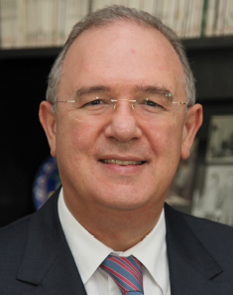

**Dr. Hasan Tayfun Özçelik**

**Dean of the Faculty of Science**

**Bilkent University**

**Ankara, Turkey**

Dr. Tayfun Özçelik graduated from İstanbul University, İstanbul Medical School in 1986. He

completed his postdoctoral work in physiology at the Ludwig-Maximilians-Universität München, and

in human genetics at the Yale University School of Medicine and at the Howard Hughes Medical

Institute, Stanford University School of Medicine. He returned to Turkey in 1992 as assistant

professor and founding head of the Department of Genetics at DETAM, Istanbul University. In 1995,

he joined the Department of Molecular Biology and Genetics at Bilkent University. He was named

associate professor in 1994 and professor in 2004. He was appointed Dean of the Faculty of

Science in 2012. His research focuses on inherited phenotypes in humans. He contributed to the

mapping of genes to human and mouse chromosomes, and identified SNRPN in Prader-Willi

syndrome, PMP22 in Charcot-Marie-Tooth disease Type IA, PHKA2 in X-linked liver glycogenesis,

MLH1 in MLH1-deficiency, VLDLR & WDR81 & ATP8A2 in cerebellar hypoplasia associated with

quadrupedal gait in humans, HTRA2 in Parkinson’s disease and essential tremors, and RAD21 in

chronic intestinal pseudo-obstruction. He introduced DNA-based individual identification to the

Turkish judiciary system and also led diagnostic genetics laboratories both at Istanbul and Bilkent

Universities. Currently, he works on the complex phenotypes of obesity and polycystic ovarian

syndrome in collaboration with Rockefeller University. Dr. Özçelik is a member of the Turkish

Academy of Sciences serving as a councilor, board member and education committee chair of the

European Society of Human Genetics, program committee member of the American Society of

Human Genetics, and past-president of the Turkish Society of Medical Genetics. He received the

TÜBİTAK Young investigator Award in 1996, Bayındır Medical Award in 2006, and TÜBİTAK

Science Award in 2012.

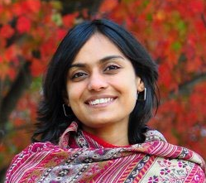

**Dr. Tejaswini Mishra**

**PostDoctoral Research Fellow**

**Stanford University**

**California, USA**

Dr. Tejaswini Mishra is a postdoctoral research fellow working on personalized medicine in the laboratory of Dr. Michael Snyder at the Genetics department of Stanford University School of Medicine in California. Her research at Stanford focuses on delineating a personal baseline of health in each individual, using longitudinal multi-omics data collected over time from human subjects. She is currently developing frameworks for integrative analysis of large multi-omics datasets (“big data”) in order to understand human-to-human molecular variation and predict personal health outcomes and disease trajectories. Dr. Mishra obtained her Bachelor’s and Master’s degrees in Biotechnology from the University of Mumbai, India, and her doctoral diploma from The Pennsylvania State University. At Penn State, she used sequencing technology to study regulation of cell fate decisions during blood cell development, ultimately discovering a fate bias in a blood cell progenitor. She also participated in the NHGRI-funded Mouse ENCODE Project, whose goal was to identify functional elements in the mouse genome. In a research career spanning 10 years, her work in understanding gene expression and regulation covers a wide variety of research areas including heterochromatinisation in fission yeast, mouse haematopoiesis and prostate cancer biology, as well as 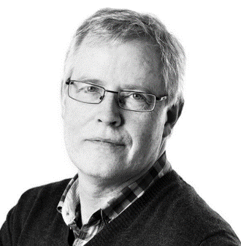personalized medicine.

**Professor Torben Hansen**

**Professor**

**University of Copenhagen**

**Copenhagen, Denmark**

Torben Hansen is Professor of Molecular Metabolism and Scientific Director at the Novo Nordisk Foundation Center for Basic Metabolic Research, University of Copenhagen, Denmark. Since 2005, he has also been responsible for molecular genetic diagnostics of diabetes and obesity at Steno Diabetes Center in Copenhagen.

Dr Hansen’s major research interests are the pathophysiology and pathogenesis of type 2 diabetes, obesity and the metabolic syndrome, and the identification of genetic determinants for both mono and polygenic components of diabetes and obesity. Furthermore, he is involved in several studies focused on the impact of the gut microbiome on disease and health

Dr Hansen is Head of The Graduate PhD Programme for Basic Metabolic Research at University of Copenhagen and is involved in pre- and postgraduate educational activities at the Universities of Copenhagen, Aarhus and Odense, and at the Steno Education Center. He has been an invited speaker at numerous international scientific meetings. He was associate editor and on the Advisory Board of Diabetologia and a member of the EASD Council. He has published more than 450 peer-reviewed original scientific articles and 22 review papers, as well as commentaries and book chapters. He has been cited more than 30,000 times and holds a H-factor of 69 according to web of science.

**Moderators’ Biographies**

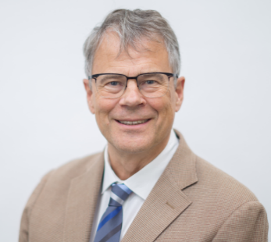

**Dr. Egon Toft**

**Vice President and Founding Dean of College of Medicine**

**Qatar University**

**Doha, Qatar**

Dr. Egon Toft is the Vice President and Founding Dean of the College of Medicine at Qatar University. He brings to Qatar University valuable experience in the establishment and leadership of institutions of medical education.  He was the Founding Dean of the Faculty of Medicine at Aalborg University in Denmark from 2010 to 2014, and an Associate Dean in the Faculty of Engineering, Science and Medicine from 2006 to 2010.

In these roles, he was responsible for educational programs in Medicine (MD), Industrial Medicine, Sports Science, Master of Science in Health Technology, Public Health and the research fields related to these programs at Aalborg University and Aalborg University Hospital. Almost all of these programs were developed under his leadership, and all are accredited. Additionally, a successful PhD program in Medicine, Biomedical Science and Technology was established under his deanship. Dr. Toft is experienced in designing and implementing problem-based learning in Bachelor and Master programs.

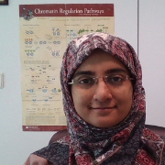A cardiologist by training (MD 1984 from Aarhus University/Dr Med.Sci. 1995 from University of Copenhagen), he was a Consultant in the Department of Cardiology at Aalborg University Hospital from 1996 to 2007, as well as Adjunct Professor (2004-2007) and later Professor in Clinical Electrophysiology (2007-2014). Dr. Toft is the author and coauthor of more than 100 peer reviewed papers, and an avid inventor (co-inventor on 7 patents) and entrepreneur (founder/co-founder of 4 biotechnology enterprises).

**Dr. Farah Zahir**

**Scientist & Assistant Professor**

**Qatar Biomedical Research Institute/HBKU**

**Doha, Qatar**

Dr. Zahir specializes in the identification of novel genetic causes for Neurodevelopmental Diseases, including rare genetic conditions as well as autism. Her PhD, awarded in 2011 by the University of British Columbia (UBC), resulted in the characterization of new ID syndromes, as well as discovery of several new causative genes. She followed with a post-doctoral tenure in Canada’s Michael Smith Genome Sciences Centre, a premiere global genomics institute, where she used whole genome sequencing methods to comprehensively assess genetic, molecular, and structural causes for ID.

Her work has garnered several accolades; among them, the coveted James Miller Prize for integrating basic and clinical science research, one of the highest distinctions awarded by the Department of Medical Genetics at UBC. She was nominated for the Governor General’s gold medal. She won five prestigious funding awards for her doctoral work and three for her post-doctoral work, among which was a fellowship from the Canadian Institute of Health Research that placed her 6th in Canada.

Dr. Zahir’s findings have been included in highly ranked academic journals as well as in features by the New Yorker magazine, among others. She serves as a research fellow at UBC, and currently heads her own group as a faculty member at Hamad Bin Khalifa University (HBKU). She is currently one of the three lead PIs on the newly formed QNRF funded consortium to study Autism in Qatar.

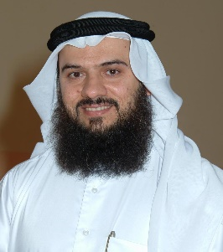

**Dr. Ibrahim Ahmed Janahi**

**Executive Director of Medical Research**

**Hamad Medical Corporation**

**Doha, Qatar**

Dr. Ibrahim A. Janahi is currently the Chairman of the National Permanent Licensing Committee (PLC) in the state of Qatar. He sat on the Establishment Committee for Qatar’s Council for Health Professionals (QCHP), the regulatory body for health practitioners in the state of Qatar.

Currently Dr. Janahi holds the key position of the Executive Director of Medical Research at Hamad Medical Corporation (HMC). In addition, since 2005 he continues to be the Program Director for pediatric training programs including program directorship of the residency program and overseeing of the 14 clinical fellowships and all the educational activities in the department of pediatrics.

His leadership roles extend beyond Qatar to the region and internationally; he is the founder and president of Gulf Society for Pediatric Respirology (GSPR) and a founding member of the Arab Pediatric Pulmonology Association (APPA). He is a member of the exam committee of the Arab Board and was instrumental in reforming the Arab Board Pediatric certifying examinations. He is an examiner for many certifying boards and qualifying examinations including but not limited to the Royal College of Pediatrics and Child Health of the UK.

Dr. Janahi is an Associate Professor of Clinical Pediatrics at Weill-Cornell Medical College in Qatar and has been actively involved in teaching learners at all levels including trainees in undergraduate and postgraduate programs. He is an active pediatric pulmonologist and is a regional reference in his field; his patient referral catchment extends to the region and internationally. His area of clinical expertise includes but is not limited to interventional pulmonology, chronic lung diseases with genetic basis and rare lung diseases in children.

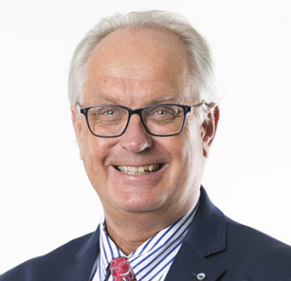

**Dr. Jan I. Olofsson**

**Division Chief of Reproductive Medicine**

**Sidra Medicine**

**Doha, Qatar**

A/Prof. Olofsson graduated with his MD degree from Umeå University, Sweden (1986), and obtained his PhD in Reproductive Endocrinology, Umeå University, Sweden (1991). During 1992 – 1994 he was Research Fellow in Reproductive Medicine at the University of British Columbia, Vancouver, Canada, where he primarily undertook the molecular characterization of the gene encoding the human GnRH receptor. He was appointed Associate Professor of Physiology (1995) and subsequently, in Obstetrics and Gynecology (1999).

He is since 2017 appointed as Division Chief of Reproductive Medicine at Sidra Medicine in Doha, Qatar to oversee the completion of a novel state-of-the art large unit, slated to open in 2018. This will be a ultramodern, all-digital, academic and full service center, which will set new standards in patient care for infertile couples in Qatar, the Gulf region and internationally. In his previous role, he was the Clinical Director and Head of Reproductive Medicine at Karolinska University Hospital, Stockholm, Sweden. This unit provides a complete range of fertility services for the greater Stockholm area (pop. 2.3 million), including assisting reproductive treatments (ART) such as IVF, ICSI, frozen embryo cycles, donor gametes, PGD and fertility preservation, with over 2800 treatment cycles started per year. Prior, he was the Asia Pacific Regional Director Medical Affairs for Reproductive Medicine at Organon, Schering-Plough and most recently MSD (Merck Inc), between 2006 - 2012. In this role, he directed the strategy for regional and global medical-marketing plans, new product launch including planning, market research, positioning and messaging, and ongoing assessment of performance. He provided scientific input Phase III-V clinical studies and educational grant projects in the Asia-Pacific region. He chaired several ad hoc medical advisory committees in Women's Reproductive Health and Fertility, and has organized and moderated scientific meetings across Asia, Europe, North and South America.

A/Prof. Olofsson’s research interests in reproductive medicine lie primarily in ovarian function and ART program management and quality control. To date, he has contributed more than 60 scholarly articles to the scientific and medical communities, and he has successfully supervised six PhD students. A/Prof. Olofsson is a member of several prestigious professional societies and he has delivered numerous invited lectures globally.

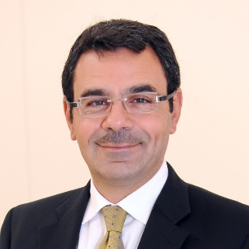

**Dr. Khaled Machaca**

**Professor of Physiology & Biophysics/Associate Dean**

**Weill Cornell Medicine**

**Doha, Qatar**

Khaled Machaca is Professor of Physiology and Biophysics at Weill Cornell Medicine and serves as Associate Dean for Research for the Qatar campus since 2008. In that capacity he oversees the academic, financial, operational and compliance aspects of the research department which currently encompasses 32 active Labs and a staff of over 200 people. This included establishing the administrative infrastructure; centralized core laboratories; and faculty recruitment & retention. He also serves as the designated institutional official overseeing the animal research program and as the director of the imaging core. Dr Machaca leads and serves on multiple institutional, national and international committees.

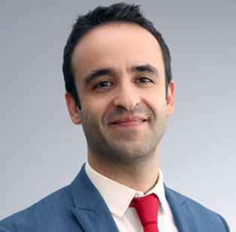The Machaca Lab is interested in intracellular signaling processes under physiological and pathological conditions with a focus on calcium signaling. Our goal is to better define these signaling pathway at the molecular level to identify therapeutic targets that can modulated to improve disease states. Our interest is focused on cell cycle regulation in the context of cancer, hypertension, and immune cell activation. Work from the Machaca Lab has been published in leading biomedical journals and garnered continuous extramural funding from NIH and the Qatar National Research Fund (QNRF). Khaled serves of several editorial boards, reviews widely for scientific journals and has a robust track record of training students and postdoctoral fellows.

**Dr. Luis Saraiva**

**Investigator- Human Genetics**

**Sidra Medicine**

**Doha, Qatar**

Luis Saraiva was born in Portugal, where in 2004, he completed a “Licenciatura” (BSc+MSc) in Biology at the University of Evora and Gulbenkian Institute of Science. He then became a Fellow of the International Graduate School in Genetics and Functional Genomics of the University of Cologne (Germany), where he received his PhD in Genetics (summa cum laude) in 2008, under the mentorship of Dr. Sigrun Korsching.

As a postdoc with Nobel Laureate Dr. Linda Buck at the Fred Hutchinson Cancer Research Center (USA), he investigated which olfactory receptors recognize pheromones and other ‘general odors’, how these environmental cues can modulate behavior and physiology, and how these cues can be translated into perception. From 2013-2015, he was an EBI–Sanger Postdoctoral (ESPOD) Fellow, in Cambridge (UK), at the labs of Dr. John Marioni (EMBL-European Bioinformatics Institute) and Dr. Darren Logan (Wellcome Trust Sanger Institute). There he pioneered the use of RNA-sequencing technologies to study how evolution or genetic variation shape the size and function of gene repertoires involved in vertebrate olfaction, and investigated the molecular identity and heterogeneity of different olfactory neuronal populations. With the Sanger Early Career Innovation Award, he extended these studies to hypothalamic neuronal populations regulating appetite, and other systems. Importantly, he helped develop a high-throughput method that allows the identification of the spatial origin of cells assayed by single-cell RNA-sequencing within a tissue of interest. This is one of the foundational studies in the nascent field of spatial transcriptomics.

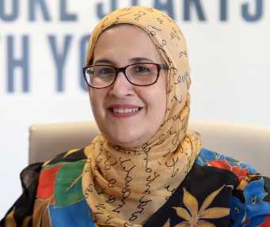

**Dr. Nahla Maher Afifi**

**Education and Scientific Manager/Acting Director**

**Qatar BioBank**

**Doha, Qatar**

Dr. Nahla Maher Afifi earned her MBBCh with honors from Ain Shams University, Egypt. She received her Master of Anatomy & Embryology, and a Diploma of Gynecology and Obstetrics from the same University. She received her Ph.D of Anatomy & Embryology in 1996 from Ain Shams University under a joint supervision with University of Medicine and Dentistry, New Jersey, USA. Dr. Afifi started her academic career as a Medical Researcher in the Department of Pharmacology and Toxicology, University of Medicine and Dentistry of New Jersey. She then served as Assistant Professor of Anatomy and Embryology at Ain Shams University, and Dubai Medical College for Girls, UAE. Dr. Afifi joined Qatar University's Biomedical Sciences Program in 1999 and was promoted to Associate Professor of Anatomy and Embryology and to Full Professor on 2007. She was assigned as a Head of Dept of Health Sciences from 2007-2010. In October 2013 she joined Qatar Foundation. She is the Education and Scientific Manager/ Acting Director in Qatar Biobank. Dr. Nahla Afifi has numerous published researches in her field of expertise (Twenty Nine published papers in international and national journals and Thirty One international conference presentations and abstracts). She is a member in the  
American Association of Anatomists (AAA), American Society of Investigative Pathology (ASIP), International Society for Biological and Environmental Biorepository (ISBER) & European, Middle Eastern and African Society of Biopreservation and Biobanking (ESBB).

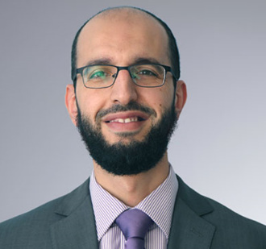

**Dr. Younes Mokrab**

**Investigator- System Biology**

**Sidra Medicine**

**Doha, Qatar**

Dr Mokrab is an experienced investigator in computational genomics, statistical genetics and bioinformatics with extensive experience from academia and the pharmaceutical industry, leading a research group at Sidra for developing and applying computational multi-omics approaches to unravel disease mechanisms with a focus on novel target discovery, validation and development of tailored therapies. He is the holder of multiple research grants, scholarships & fellowship awards, most recently a QNRF as lead PI for $1 million. So far, he has h-index of 16, with 35 peer-reviewed publications including 8 in Nature journals and is an invited speaker in numerous conferences. He is a frequent reviewer and editor for the Journal of Translational Medicine.

Dr Mokrab has 14 years of multi-disciplinary quantitative biology research experience from established academic institutions and big pharma working in disease themes overarching genetics, immunology and neuroscience. Geneticist by training, he completed a PhD from the University of Cambridge in statistical bioinformatics in 2007. He then did a postdoc at the University of Oxford studying ion channelopathies using multiscale simulation and electrophysiology approaches. Next, he moved to Lonza Biologics UK as a consultant in early-stage in silico biologics development including antibody engineering, deimmunisation and vaccine design. Prior to joining Sidra, he was at Ely Lilly UK where he led computational research into the genetics of neuropsychiatric disorders and the discovery and validation of novel targets.

Dr Mokrab has a strong track record in leading and managing research and played leading roles in multiple international consortia & public-private partnerships including Psychiatric Genomics Consortium (PGC), NIH Accelerated Medicines Partnership, EMBL-EBI industry programme, Brain research consortium by Lieber Institute (LIBD), The Cancer Genome Atlas (TCGA) and most recently the Qatar Genome Project (QGP) Consortium. He also has industry-certified corporate project management & customer engagement, with research consultancy experience interfacing with customers and partners.

Information about Sidra Medicine

Sidra Medicine, a member of Qatar Foundation for Education, Science and Community Development, is a new and ultramodern academic medical center in Doha, Qatar with a focus on three key areas:

* World-class healthcare for women and children
* Medical education
* Biomedical research

With the aim of becoming a center of excellence, Sidra has been designed to the highest international standards, with state of-the-art medical equipment and sophisticated laboratories to nurture innovation and clinical advancement. Sidra will bring together the world’s most distinguished healthcare professionals to provide the highest level of medical care for patients and families.

Vision

Sidra Medicine will be a beacon of learning, discovery and exceptional care, ranked among the top academic medical centers in the world.

Mission

Sidra will provide patients with world-class healthcare services in an innovative and ultramodern facility specially designed to promote healing. In particular, it will initially address the growing need for more comprehensive patient- focused medical services for women and children in Qatar and throughout the region.

In collaboration with the premier medical school in Education City – Weill Cornell Medicine-Qatar, leading research institutions worldwide, and Qatar’s health sector, Sidra will provide a diversity and quality of care conducive to training medical students and highly skilled clinicians and will be a pioneer in clinical and translational biomedical research of value to the population of Qatar and the world.

Construction and Design

Designed by renowned architect César Pelli, Sidra features a main hospital building and a separate outpatient clinic. The main hospital will initially have 400 beds with infrastructure to enable expansion to 550 beds in a subsequent phase. The cuttingedge structure of steel, glass and white ceramic tiles was chosen to provide the ideal environment for tranquility, privacy and healing. The main hospital building incorporates three towering atriums that serve as indoor healing gardens - a unique feature that every patient will be able to view from his or her luxurious private room - and soothing water features, as well as an impressive art collection.

Patient Care

Sidra opened its outpatient clinic in May 2016 and offers outpatient services for children and obstetrics care for women through a referral based system in partnership with primary and secondary healthcare providers in Qatar. With a strong patient and family centered focus, the Sidra Outpatient Clinic is a high-tech facility that aims to deliver outstanding treatment and care, safely and efficiently. It is expected to be fully operational by 2017 with over 40 clinics and services. Once the main hospital opens, it is anticipated that more than 10,000 pregnant women will be cared for at the center, including 2,000 high-risk deliveries. Sidra will also offer services in benign gynecology and reproductive medicine. As the specialty pediatric hospital for Qatar, it will offer neonatal, general medicine, genetics, hematology/oncology, transplantation, interventional cardiology, oncology, trauma and surgical care inclusive of orthopedics, urology, plastics, ophthalmology and Ear, Nose and Throat (ENT) services.

Biomedical Research

Sidra’s research branch will emphasize investigations relevant to women and children’s health, in line with the Qatar National Research Strategy. Sidra will facilitate the prevention of, and early intervention for, conditions affecting the local population – in particular, women and children – including cancer, obesity, preterm birth and genetic disorders. Sidra’s research branch includes three key divisions – experimental genetics, translational medicine and biomedical informatics. Sidra’s diverse team of researchers, scientists and principal investigators lead a series of biomedical and clinical research programs designed to advance the understanding of the mechanisms of diseases; develop early prevention and therapeutics; as well as identify accurate diagnostics. The core focus of Sidra’s Research branch is to support the organization and its staff to practice personalized healthcare in all facets of healthcare delivery through the concept of personalized medicine.

Technology

Sidra will be a ‘paper-lite’ medical center, incorporating the most advanced digital applications in clinical, research and business functions. All systems will be focused on integrative data flows, eliminating redundant processes and enhancing patient care and safety. Sidra will be equipped with state-of-the-art robotics, computer-aided surgery and diagnostics, and 3D+ digital imaging.

Recruitment

Sidra will offer unique and unprecedented opportunities for leading health professionals to be pioneers in the discovery of knowledge and the advancement of patient and family centered care.

Sidra expects to employ more than 5,000 employees in clinical and nonclinical roles. The center is currently seeking experienced and talented individuals.

Information about Sidra Research Branch

The Research Branch at Sidra serves as a hub for biomedical investigation in Qatar to facilitate the process of clinical testing and discovery by adopting advanced technologies. Its aim is to advance the understating of mechanism of diseases; to develop preventive, diagnostic and therapeutic tools; and to improve the health outcomes of the women and children of Qatar.

The Research Branch has launched its Five-Year Strategic Plan from 1 April 2015 to 31 March 2020, which outlines highlevel concepts and the scope of research by prioritizing investigation and addressing biomedical problems that are national relevance and of global impact. As part of this strategy, the research team will prioritize translational research programs that link to diseases relevant to Qatar and region.

The key areas of research include:

* Developmental and preventive medicine
* Neonatal medicine, pediatric and adolescent preventive medicine, addressing issues such as inborn errors of metabolism and postnatal conditions of the infant such as hypothermia, malnutrition and infection
* Pregnancy, health and fertility
* Women’s health
* Research programs in genomics, diabetes, cancer, cardiovascular diseases; addressing issues such as gestational diabetes, gynecological cancers and hypertensive disorders of pregnancy
* Monogenic disorders treated via gene therapy or gene replacement therapy.

The main research laboratories at Sidra will cover 10,000m2 with a core space of 1,558 m2 that will be available for all research groups at Sidra. The cores include: next generation Sequencing (NGS) and functional genomics (Experimental); NGS and advanced molecular clinical testing (CLIA level, with Clinical Laboratory); Deep phenotyping; Experimental imagine; Good manufacturing practice cell processing lab (to support stem cell program); Metabolomics; Proteomics; Bioinformatics core.

The Research Branch aims to develop world leading science and research programs that will align with Qatar’s national research strategy and also help address other public health issues. The focus of the Research Branch is to support clinicians to practice personalized healthcare in all facets of the healthcare delivery with Sidra. Most of the research in research branch at Sidra will underpin the concept of personalized medicine.

For more details about Sidra’s research branch and its five years’ strategy, please visit:

[www.sidra.org/biomedical-research-branch](http://www.sidra.org/biomedical-research-branch)

About Qatar

Archaeological evidence show human habitation of Qatar dating back to the Stone Age, and that there was a healthy seagoing community in the peninsula as early as 5000 BC. Hunting, gathering and fishing supported these early communities.

In medieval times, Qatar was an important trading post in the Gulf-Indian Ocean commerce. It was dominated by the Ottomans in the 19th century and then became a British protectorate in 1916. The arrival of oil prospectors and the establishment in 1935 of Petroleum Development Qatar signaled the beginning of a new era. Since gaining independence in 1971, the sovereign state has transformed itself into an economic powerhouse.

The ruling Al Thani family, a branch of an ancient Arab tribe, settled in Qatar during the early 18th century. The current Emir is His Highness, Sheikh Tamin Bin Hamad Al Thani.

Despite ongoing 21st century advancements, Qatar places great value on its most important possession, its rich cultural heritage. Customs and traditions are still widely observed and historical sites are well-preserved.

Blend of Old and New

The stunning urban landscape of Doha can make one forget that the beginnings of Qatar date back 7,000 years. Qatar always fascinates with its contrasting, open, 21st century society that is rooted in culture and history. It has soaring skyscrapers and beautiful mosques, local souqs and upscale malls, falcons homing back to their masters, jets that cut through the sky, historic forts and futuristic hotels, camel races and international sporting events.

## **Key Industries**

Oil and gas production are the drivers of Qatar’s economy. Oil production capacity is 850,000 barrels per day. Qatar is the largest global exporter of liquefied natural gas (LNG) producing some 38 million tons annually. Efforts to diversify the economy are high on the agenda. The result is a broad range of growth industries including banking, telecommunications and IT, fertilizer production, aluminum smelting, construction, tourism, and real estate.

## **Culture**

Qataris are passionately committed to upholding their heritage and cultural values while forging one of the most advanced societies in the world. Its ancient history can be glimpsed in carefully preserved heritage sites including forts and prehistoric settlements where rare petroglyphs have been discovered.

In the metamorphosing capital city of Doha itself, the passion for capturing and reviving Qatar’s cultural heritage is felt everywhere – magnificent museums housing priceless artefacts, restored Bedouin souqs, merchant houses, and royal residences, prestigious races and shows purely for Arabian horses, and traditional wooden dhows plying the bay.

## **Climate**

The climate is characterized by a mild winter and a hot summer. Rainfall in the winter is slight, averaging some 80 millimeters a year. Temperatures range from 7 degrees centigrade in January to around 45 degrees at the height of summer (July and August). The weather is generally pleasant from October until May.

Safety & Security Doha is recognized as one of the safest cities, and Qatar as one of the safest countries in the world. Business travelers arriving alone or with their families for the Symposium can take confidence in Qatar’s 2014 ranking by the Global Peace Index as the 22nd most peaceful of 162 nations of the world.

Conference Sponsors and Exhibitors

## **We thank our sponsors and exhibitors**

Diamond

* Alliance Global FZ LLC
* Philips Middle East
* WuxiNextCode
* Weill Cornell Medicine- Qatar

Platinum

* Sedeer Medical Services
* St. Regis Hotel

Gold

* Specialized Medical Solutions
* Qiagen Manchester Ltd
* Atrium Medical Care WLL

15% Discount

* Qatar Airways

Notes:

________________________________________________________________________________________________________________________________________________________________________________________________________________________________________________________________________________________________________________________________________________________________________________________________________________________________________________________________________________________________________________________________________________________________________________________________________________________________________________________________________________________________________________________________________________________________________________________________________________________________________________________________________________________________________________________________________________________________________________________________________________________________________________________________________________________________________________________________________________________________________________________________________________________________________________________________________________________________________________________________________________________________________________________________________________________________________________________________________________________________________________________________________________________________________________________________________________________________________________________________________________________________________________________________________________